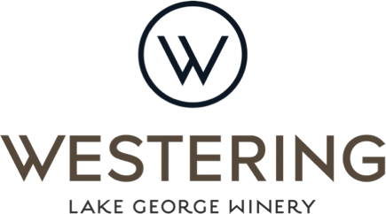
Charcuterie Board to share
Warm sourdough with cultured butter and sea salt - 8
Warm mixed marinated olives - 8

Selection of Charcuterie, pickled vegetable, toasted ciabatta - 36
Selection of Australian & international premium cheese, dried fruit, muscat grapes, lavosh. - 36
2 courses $55 3 course $70
Entrée
Cured salmon, fennel, hazelnut, radish - LGW Rose
Vegetable terrine, feta cream, rocket – LGW Semillon Sauv Blanc
Pork braun, pumpkin, kale, balsamic – LGW Riesling.
Beef carpaccio, black garlic aioli, caperberries, parmesan – LGW Pinot Noir
Mains
Potato pave, pomme puree, baby carrots, crème fraiche - LGW Semillon Sav Blanc
Beef fillet, potato fondant, baby leeks, jus – LGW Shiraz
Chicken breast, Jerusalem artichoke, corn & basil – LGW Chardonnay
Barramundi, cauliflower, lemon & caper butter – LGW Riesling
Sides additional
Fries, Cajun sea salt and black garlic aioli - 9
Sautéed Spring vegetable, beurre noisette and toasted almonds. - 10
Mixed leaves, Spring shoots, French style vinaigrette - 8
Something Sweet
Coconut panna cotta, mango, lemon myrtle
Chocolate parfait, orange & bay marmalade, almond praline
LGW Pavlova, mulled rose berries, passionfruit cream
Cheese plate

LGW Rose Gin, dash of elderflower, shaved apple and tonic 15
LGW Sparkling Cosmo, vodka, triple sec, cranberry, lime, sparkling 18
Beer and Cider
Bentspoke – Barley Griffin Pale Ale 11
Peroni Red 9 Peroni Blue 9
Boags Light 7 Hawkers – Rover session IPA 8.5
Great Northern, super crisp 8
Capital Brewing Co, Springboard Wit 10.5 Corona 8
Batlow oaked pear cider 9.5 Alpine dry apple cider 9.5
Spirits 10
Soft Drinks
Beloka mineral water 12
Lemonade, coke, Lemon/lime/bitters, squash 4
TEA – Organic English Breakfast. Organic French Earl Grey, Organic Japanese sencha
COFFEE – The Little Marionette
CHILDRENS MENU 25
Banger and mash with gravy
Crispy battered fish and chips with tomato sauce Chicken nuggets and chips With tomato sauce
Then
Ice cream and topping
Sundays and public holidays attract a 5% surcharge
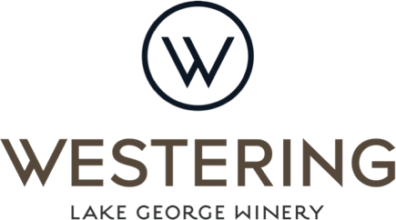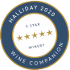
White Wine
2019 Semillion Sauvignon Blanc G 12 B 42
Fresh, light and with a short finish.
2019 Pinot Gris G 12 B42
A fragrant bouquet with a spread of fruity aromas from citrus to stone
2019 Riesling G 14 B50
Flavours of lime & lemon & light embedded slate acidity

2019 Chardonnay G12 B45
A light & fresh chardonnay with a nice buttery palate
Red Wine
2017 Pinot Noir G 15 B60
Engaging wine full of expressive summer red berries & subtle cinnamon spice
2019 Weereewaa Red G 15 B50
Dense, ripe, spicy nose & fresh black fruits dominating with great length & elegance
2019 Shiraz G 15 B50
Fresh, bright red & blue fruits, light florals, brown spices & pure raspberry
that are mirrored on both the nose & the palate
Rose
Rae Rose G12 B42
Genache & Negramaro blend, light, crisp, berries & dry finish
2020 Rose G12 B42
Light, crisp, savoury with peach & apricot
Dessert
2020 Sweet Pinot Gris G12 B25
2019 Fortified Shiraz G15 B45
Sparkling LGW Sparkling G15 B60
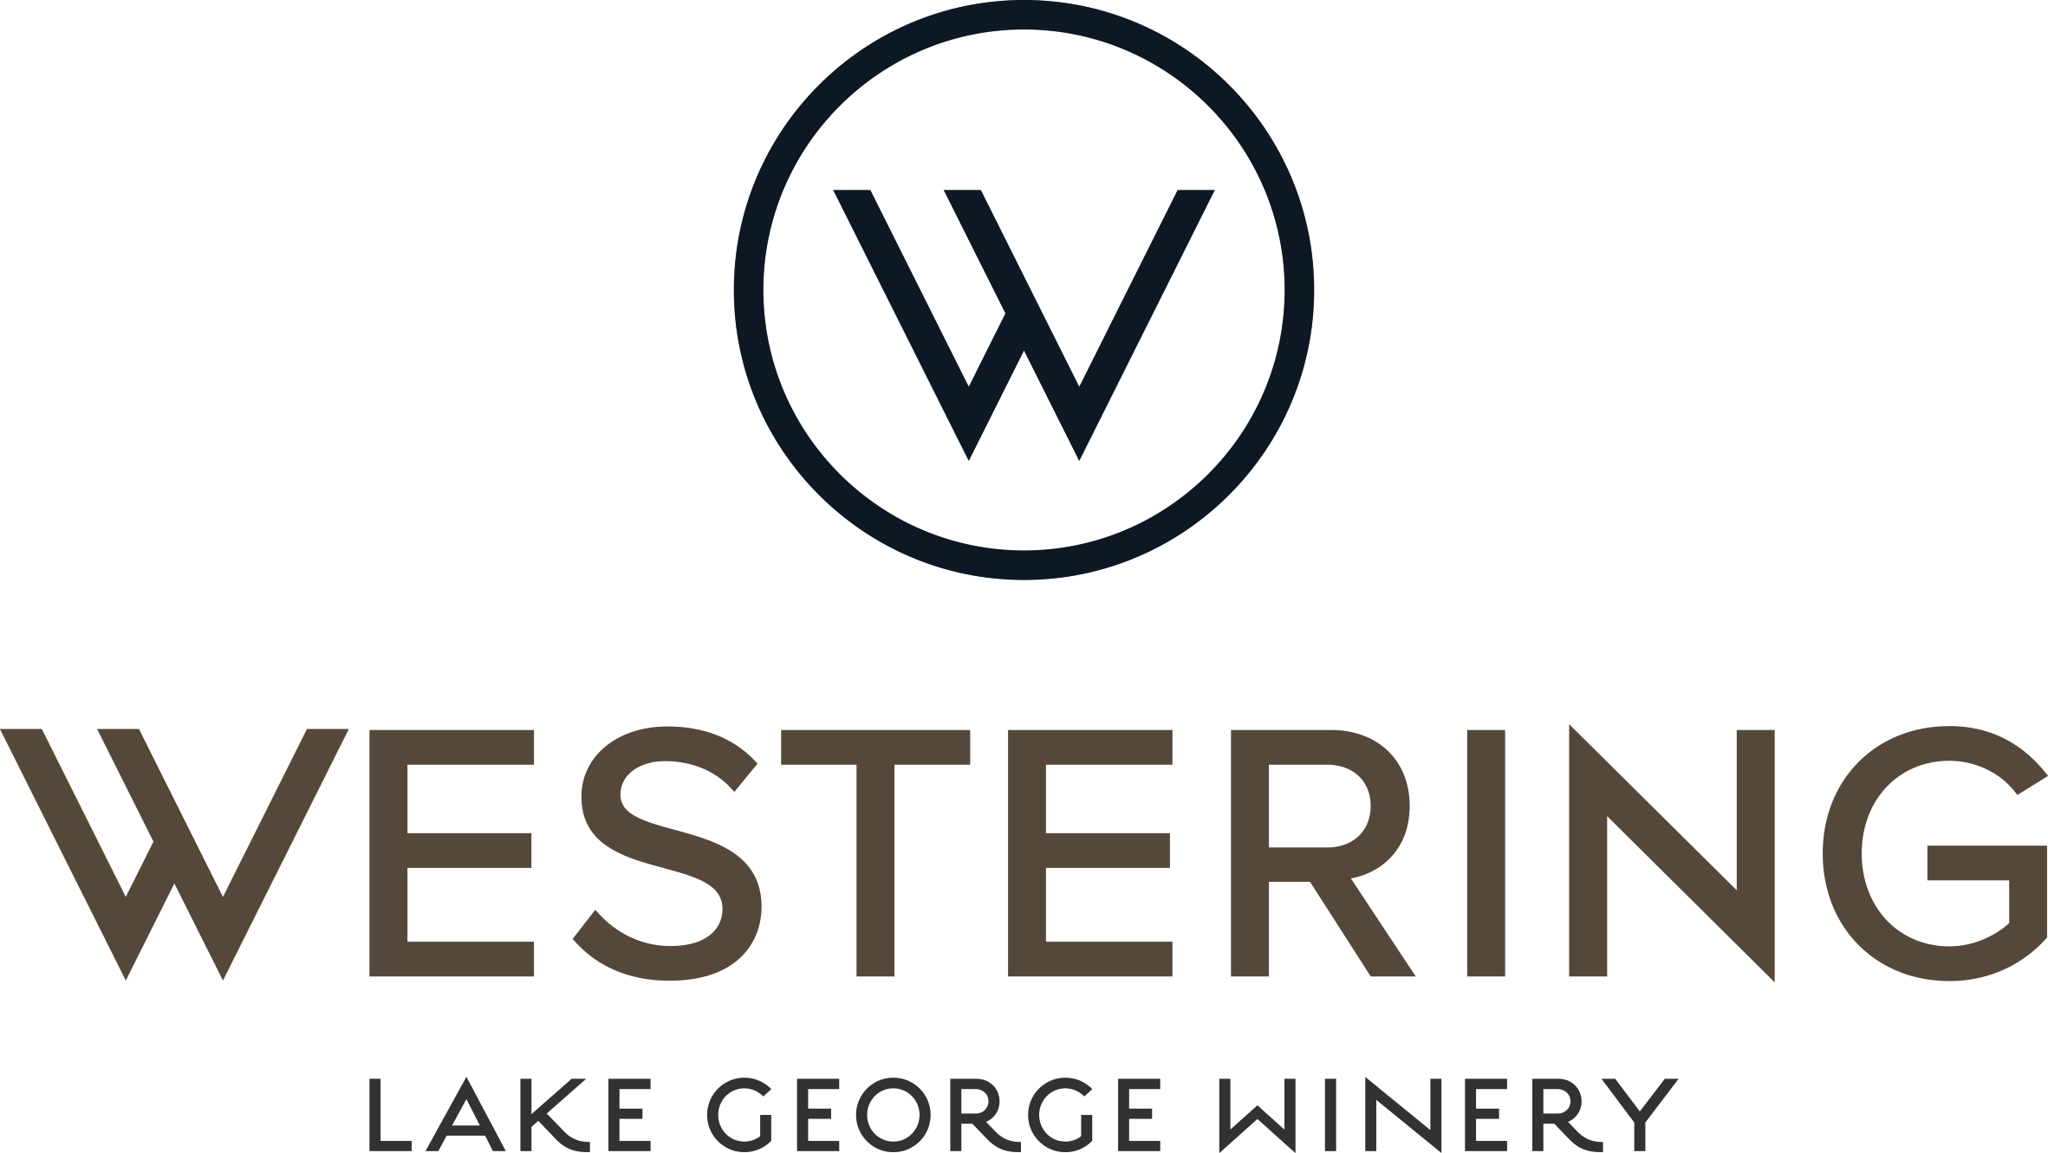  In the restaurant……  So happy to welcome our new Chef James Titheradge and running our dining room is Zeljka Seselja . You’re in very safe hands.  Event news…….  Sneaky Sound System on 14th November. Tickets through Eventbrite. General admission or VIP or LUX tickets available.  Winery news……recent awards  2019 Riesling  BRONZE - International Riesling Challenge 2019  SILVER Rated 92 Points - Halliday Wine Companion 2021  BRONZE – NSW Wine Awards 2020  2019 Chardonnay  SILVER Rated 93 Points – Halliday Wine Companion 2021  SILVER – Canberra & Region Wine Show 2019  2017 Pinot Noir  GOLD Rated 95 Points - Halliday Wine Companion 2021  BRONZE - Canberra & Region Wine Show 2019  2019 Shiraz  SILVER – NSW Wine Awards  Women in Wine Awards hosted by Wine Australia, 2019  Owner/Operator of the Year, Sarah McDougall  Halliday 5 Star Winery 2019, 2020, 2021  Beautiful time of year in the Vineyard with ‘spring burst’ in full swing.  We are pesticide free, vegan friendly and all of bottles are Australian made.  Book a tasting with Sarah or one of our staff in the restaurant.  Follow us on westering_lakegeorge | Coming up……..  We have gift cards for Christmas and beautiful hampers  Talk to Sarah about our wine and vine tours  Corporate Christmas party packages available now. We offer $10pp towards your transport. Min numbers apply.  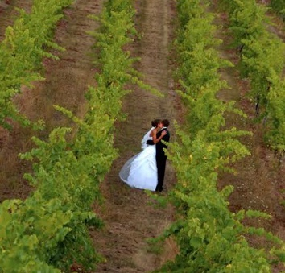  Wedding ceremony & reception bookings available for 2020  